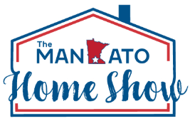


2026 Mankato Home Show Visibility Package

Stand Out at Southern Minnesota’s Premier Home Event
Maximize your visibility and make a lasting impression at the 2026 Mankato Home Show. Choose from high-impact digital and in-person sponsorships designed to get your brand in front of thousands of attendees all weekend long. Visual Exposure Options
Floor Stickers (4 available)
- 4 full-color adhesive graphics (2ft x 2ft)
- Strategically placed in high-traffic areas
- Great for branding, QR codes, or interactive messaging
Monitors & Projectors (10 available)
- 5 hallway monitors featuring rotating ad spots throughout the day
- 6 large projectors in main show spaces (Banquet & Grand Halls)
- Perfect for videos, slideshows, or animated brand messages

B2B Visibility Opportunities
Vendor Party Sponsor (3 available)
- Business mentions during the Friday night Vendor Party
- On-site signage at the event
Vendor Break Room Sponsor (2 available)
- Exclusive signage in the vendor break area
- Business mention at the Vendor Party
Choose Investment Options
Package | Price
___ Floor Stickers | $1,000
___ Monitors & Projectors | $1,000
___ Floor Stickers + Monitors & Projectors | $1,750
___ Vendor Party Sponsor | $1,300
___ Vendor Break Room Sponsor | $750
Business Name: ____________________________________________
Approved by: _________________________ Date: ___________

